1. Requirement: https://codelabs.developers.google.com/codelabs/cloud-tensorflow-mnist#13

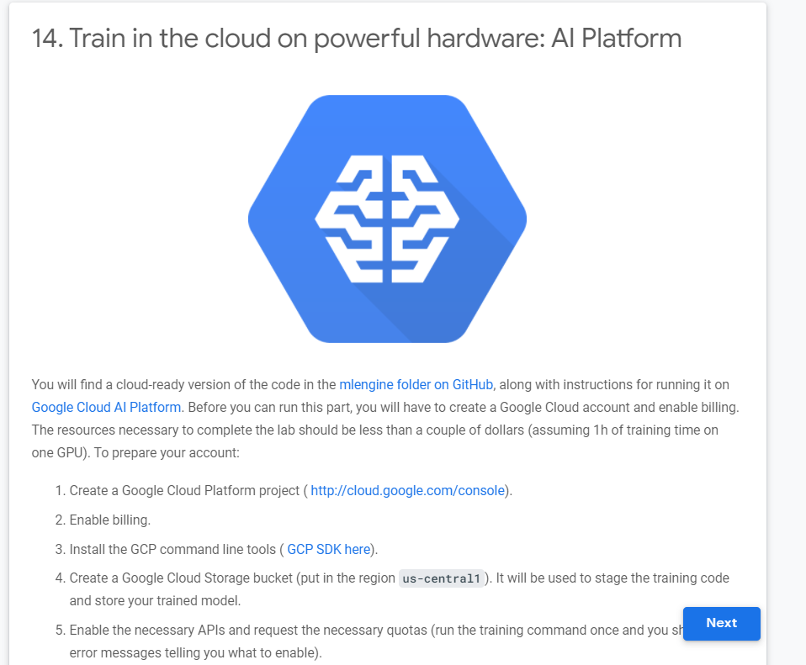

2. Install and setup GCP SDK for the account - subarnachowdhury.soma@sjsu.edu

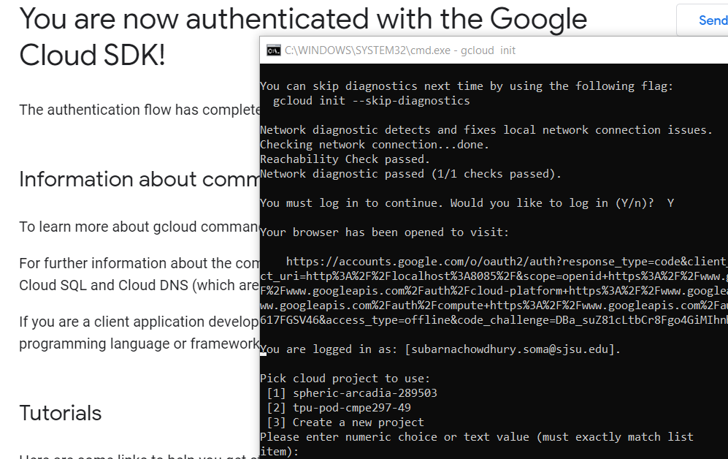

3. Project created named: subarna-hw1p2

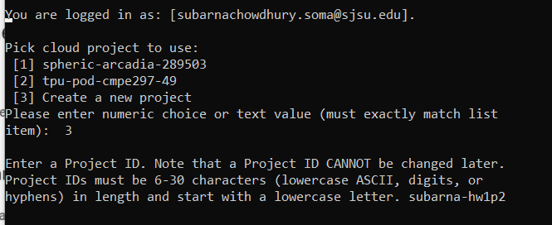

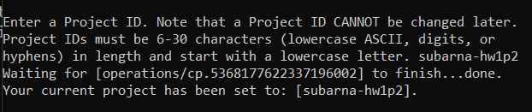

4. Created storage bucket: subarna-hw1p2-bucket1

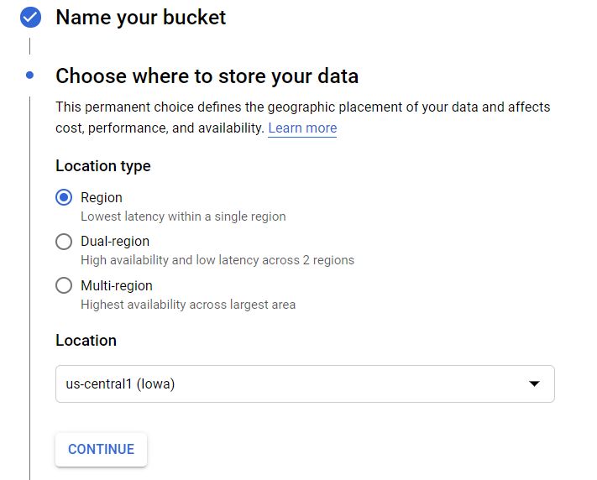

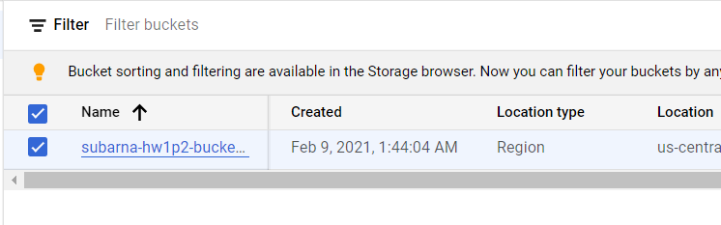

5. Enabling service API/region

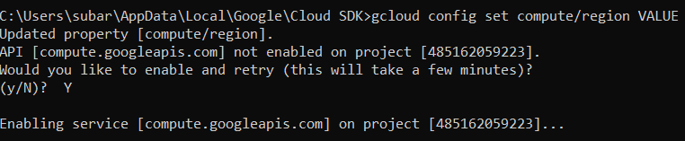

6. Successfully submit the jobs sample from mlengine tutorial in AI Platform using this command and deployed the model:

Ref: gcloud ml-engine jobs submit training jobXXX --job-dir gs://<bucket>/jobs/jobXXX --project <project> --config config.yaml --module-name trainer.task --package-path trainer --runtime-version 1.15

**gcloud ml-engine jobs submit training joba1_ --job-dir gs://subarna-hw1p2-bucket1/jobs/joba1_ --project subarna-hw1p2 --config config.yaml --module-name trainer.task --package-path trainer --runtime-version 1.15**

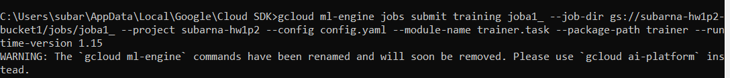

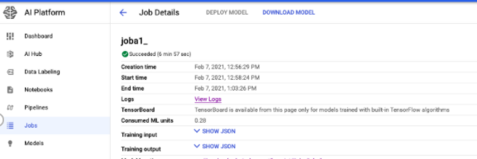

7. Created Model cnn_model and training in the cloud

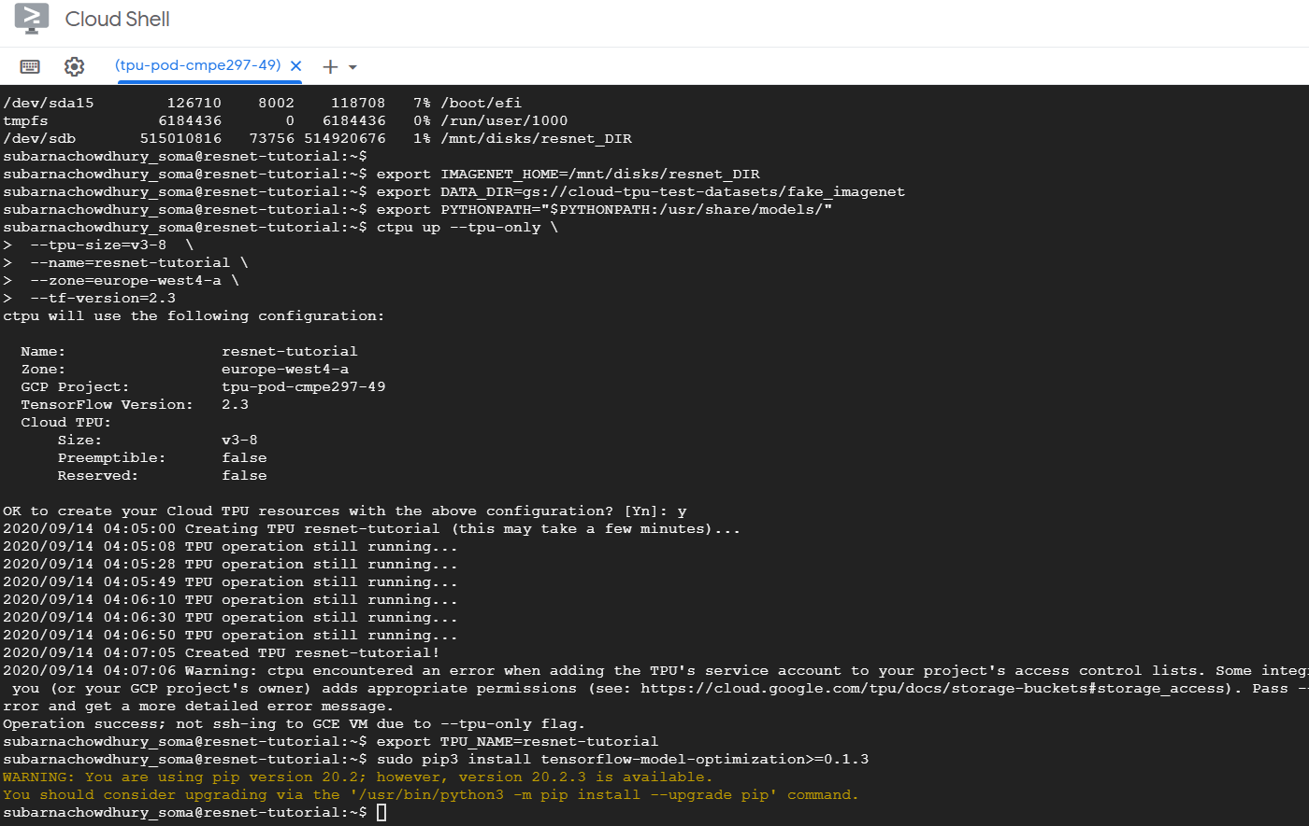

8. Trained Model In GCP platform

Task complete, then disabled billing process for this project:

